OpenComm
Design Suggestions Version 2
Nora Ng-Quinn

Main Chat Window
This window always holds everyone who is part of the conference, and is the first screen to show up. Everyone person is represented by a unique icon and name. At the bottom of the screen are a MENU button, a MAIN button, and a scrollable list of icons that represent all available Private Spaces.
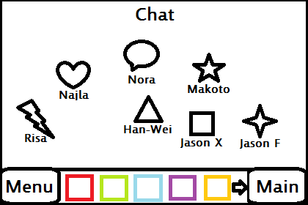

You may scroll through all your Private Spaces by touching and dragging left or right. The arrows indicate whether you have more icons that you cannot see currently. Tapping once on a Private Space icon will pop up a small preview of all the people who are in that specific Private Space. Tapping a second time will take you to that Private Space’s screen and allow you to talk to only that Private Space.

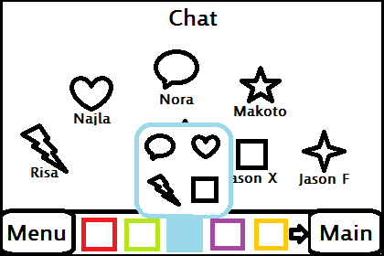

You can add or delete Private Spaces by using the Menu button, which will add a Private Space icon to the bottom of your screen, or delete a Private Space’s icon if you have selected the icon.

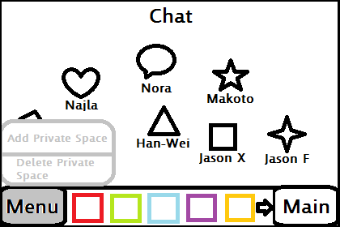

You can add people to a Private Space by dragging their icons into a Private Space icon. This will automatically highlight the icon and pop up its preview.

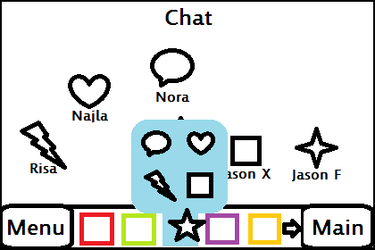

Private Space Window
This window shows only the people involved in this Private Space, and being in this window indicates that only the people in this Private Space can hear what you say. At the bottom of your screen are the icons of everyone involved in the main conference. You may return to the Main Conference window easily by tapping on the MAIN button. The icons of those who are involved in this specific Private Space are highlighted and automatically moved to the left. You may scroll through the icons if there are too many to fit on the bottom bar.
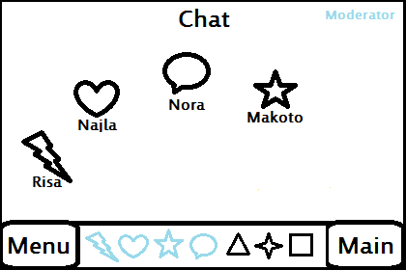

You may add or delete people from this Private Space either if you are the creator of the Private Space (denoted by the word MODERATOR at the top-right of your screen) or if you are the only person in this Private Space.

Should you wish to add someone to this Private Space, you may drag their icon from the bottom bar into the window screen. Their icon should show up in the screen afterward. (I messed up the picture, their icon at the bottom bar should then turn blue and move to the left of the screen).

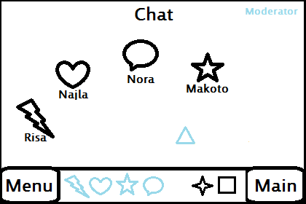
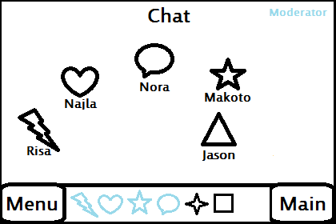

You may remove people from this Private Space by dragging the person’s icon back into the bottom bar.

